

DATABASE SPECIFICATIONS

Next-Gen Restaurant Application
Krishna Chaithanya Reddy Atla – kma6396@psu.edu
Abhishek Reddy Tetali – aft5636@psu.edu

School of Graduate Professional Studies
Information Science Department
IN SC 521 - Introduction to Database Concepts

October, 2023

Document Control

Work carried out by:
Name | Email Address | Other
Krishna Chaithanya Reddy Atla | kma6396@psu.edu
Abhishek Reddy Tetali | aft5636@psu.edu

Revision Sheet

Release No. | Date | Revision Description
1 | 30-10-2023 | Added Database Requirements
2 | 05-11-2023 | Added Conceptual Design
3 | 12-11-2023 | Added Logical Design
4 | 26-11-2023 | Added Normalization
5 | 03-12-2-23 | Added Physical Design

DATABASE SPECIFICATIONS

TABLE OF CONTENTS

Document Control i
Work carried out by: i
Revision Sheet i
Milestone 1: Data Requirements 1
Purpose 1
Outcomes 1
Student contribution 1
System Name or Title 1
Core requirements 1
Milestone 2: Conceptual Design 2
Purpose 2
Outcomes 2
Student contribution 2
Entity Relationship Diagram 2
Assumptions and Constraints 3
Milestone 3: Logical Design 4
Purpose 4
Outcomes 4
Student contribution 4
Entity Relationship Diagram 4
Assumptions and Constraints 5
Milestone 4: Normalization and 6
Milestone 5: Physical Design 6
Purpose 6
Outcomes 6
Student contribution 6
Assumptions and Constraints 6
Naming Conventions 6
Tables 6
Examples of values 6
Notes 6
Milestone 6: SQL queries and 8
Purpose 8
Outcomes 8
Student contribution 8

Milestone 1: Data Requirements

Next-Gen Restaurant Application

Core requirements

No. | Requirement | Referenced page in SRS | Referenced Section in SRS | Referenced Paragraph in Section
1 | Customers are the primary stake holders. | 7 | Table | Row 2
2 | The Database should contain information about the customers | 7 | Table | Rows 2
3 | The Database should contain information about the restaurant’s tables (e.g., table number, table capacity, shape, or layout(assumptions)) and their availability and table maps | 3  10 | 1.2  3.5.2 | 1.2.1,1.2.2  3.5.2.8
4 | The Database should contain information about the restaurant’s employes (which includes servers, hosts/hostesses, Kitchen Staff, Restaurant Managers) and their schedules. | 6 | 2.3 | Point 2
5 | The Database should contain information about the menu of the restaurant (to order the customer need to have a menu) | 5 | 2.2 | Point 3
6 | The Database should contain information about the order history | 5 | 2.2 | Point 3
7 | The Database should contain information about the reservations | 5 | 2.2 | Point 7
8 | The Database should contain information about the kitchen inventory | 7 | Table | Row 5  Column 3
9 | The Database should contain information about the payment made towards an order which also includes gratuities | 9 | 3.5 | 3.5.1.4,3,5,1,5
10 | The Database should contain information about the waiting queue | 10 | 3.5 | 3.5.3.1
11 | The Database should contain information about the user’s login details | 13 | 5.1 | 5.1.1,5.1.2
12

Milestone 2: Conceptual Design

Diagram

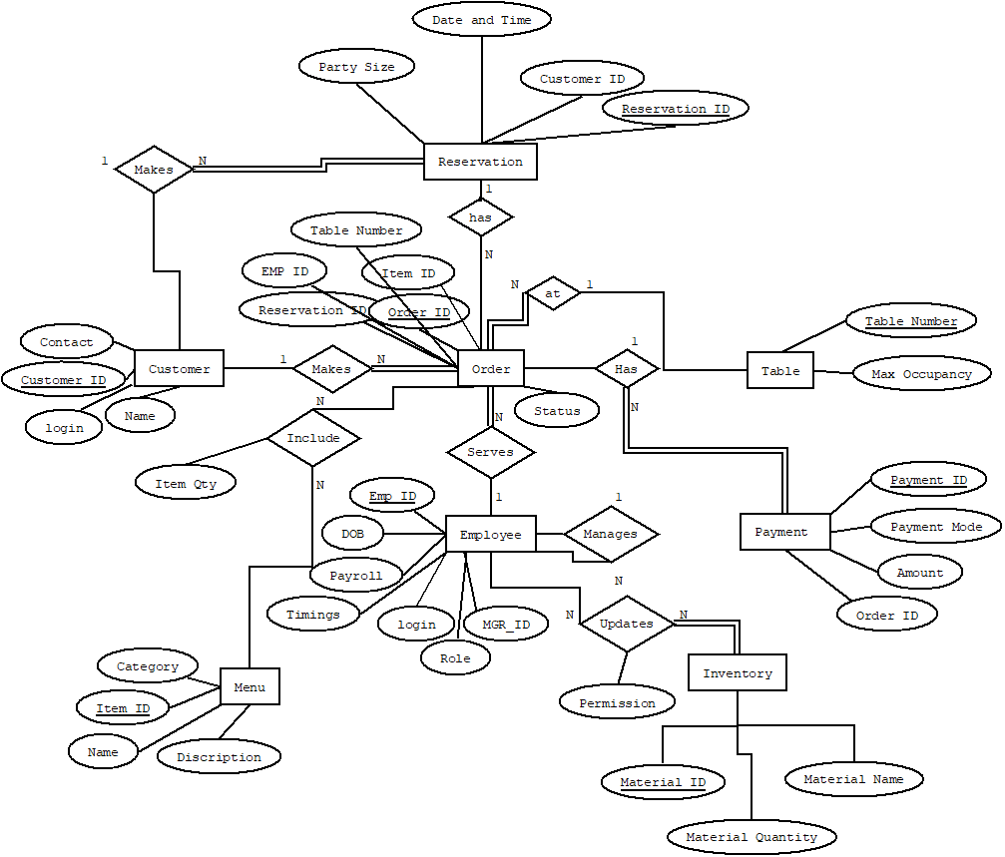

Assumptions and Constraints

1)The Payment information will have Sales Tax on every order.
2)The menu will have only those items which can be prepared from the current inventory.
3)Customer id, Order id, Payment id are key attributes.
4)Staff members can be customers also.

Milestone 3: Logical Design

Entity Relationship Diagram
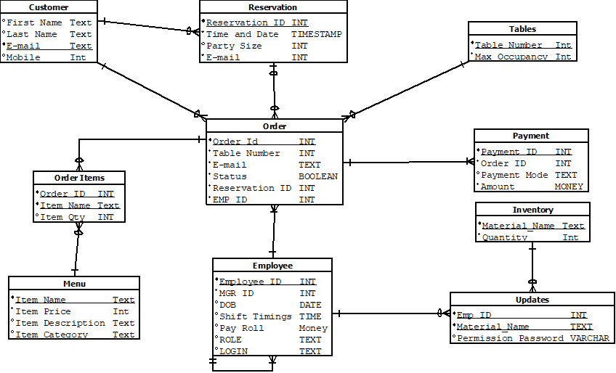

Entity name: Table
Attributes: Table Number, Max Occupancy
Functional dependencies: Table Number → Max Occupancy
Attributes not in FD | Attributes on the left | Attributes on both sides | Attributes on the right side
 | Table Number |  | Max Occupancy

Attribute closures (if any):
Table Number+ = Max Occupancy
Table Number is a super key, candidate key, primary key

Unique keys: the key for this table is/are

Table Number

Entity name: Orders
Attributes: Order ID, Table Number, Email, Status, Reservation ID, Emp ID
Functional dependencies: 1) Order ID → Table Number, Email, Status, Reservation ID, Emp ID
Attributes not in FD | Attributes on the left | Attributes on both sides | Attributes on the right side
 | Order ID |  | Table Number, Email, Status, Reservation ID, Emp ID

Attribute closures (if any):
Order ID+ = Table Number, Email, Status, Reservation ID, Emp ID

Order ID is a super key, candidate key, primary key.

Unique keys: the key for this table is/are.

Order ID

Entity name: Menu
Attributes: Item Name, Item Description, Item Price, Item Category
Functional dependencies: 1) Item Name → Item Description, Item Price, Item Category
Attributes not in FD | Attributes on the left | Attributes on both sides | Attributes on the right side
 | Item Name |  | Item Description, Item Price, Item Category

Attribute closures (if any):
Item Name+ = Item Description, Item Price, Item Category

{Item Name} is a super key, Item Name is a candidate keys, Item Name is a primary key.

Unique keys: the key for this table is/are.

Item Name

Entity name: Customer
Attributes: First Name, Last Name, Mobile, Email, password
Functional dependencies: 1) Email → First Name, Last Name, Email, Mobile
Attributes not in FD | Attributes on the left | Attributes on both sides | Attributes on the right side
 | Email |  | First Name, Last Name, password, Mobile, Email

Attribute closures (if any):
Email + = First Name, Last Name, Mobile, Email, password

{Email} is a super key. Email is the candidate key; Email is a primary key.

Unique keys: the key for this table is/are.

Email
Entity name: Reservation
Attributes: Reservation ID, Time and Date, Party size, Email
Functional dependencies: 1) Reservation ID → Time and Date, Party size, E-mail

Attributes not in FD | Attributes on the left | Attributes on both sides | Attributes on the right side
 | Reservation ID |  | Time and Date, Party size, Email

Attribute closures (if any):
Reservation ID+ = Reservation ID, Time and Date, Party size, Email

Reservation ID is a super key, candidate key, primary key.

Unique keys: the key for this table is/are.

Reservation ID

Entity name: Employee
Attributes: Emp ID, DOB, payroll, shift timings,role,password, MGR ID
Functional dependencies: 1) Emp ID → DOB, payroll, shift timings,role,password, MGR ID

Attributes not in FD | Attributes on the left | Attributes on both sides | Attributes on the right side
 | Emp ID |  | DOB, payroll, shift timings, role, password, MGR ID

Attribute closures (if any):
Emp ID+ = Emp ID, DOB, payroll, shift timings, role, MGR ID

Emp ID is a super key, candidate key, primary key.

Unique keys: the key for this table is/are.

Emp ID

Entity name: Payment
Attributes: Payment ID, Order ID, Payment Mode, Amount
Functional dependencies: 1) Payment ID → Order ID, Payment Mode, Amount

Attributes not in FD | Attributes on the left | Attributes on both sides | Attributes on the right side
 | Payment ID |  | Order ID, Payment Mode, Amount

Attribute closures (if any):
Payment ID+ = Payment ID, Order ID, Payment Mode, Amount

Payment ID is a super key, candidate key, primary key.

Unique keys: the key for this table is/are.

Payment ID

Entity name: Inventory
Attributes: Name, Quantity
Functional dependencies: 1) Name → Quantity

Attributes not in FD | Attributes on the left | Attributes on both sides | Attributes on the right side
 | Name |  | Quantity

Attribute closures (if any):
Name + = Name, Quantity

Name is a super key, candidate key, primary key.

Unique keys: the key for this table is/are.

Name
Entity name: Order Items
Attributes: Order ID, Item Name, Item Qty
Functional dependencies: 1) Order ID, Item Name → Item Quantity

Attributes not in FD | Attributes on the left | Attributes on both sides | Attributes on the right side
 | Order ID, Item Name |  | Item Quantity

Attribute closures (if any):
Order ID, Item Name + = Order ID, Item Name, Item Qty

{Order ID, Item Name} is a super key, Order ID, Item Name are candidate keys, Order ID, Item Name is a primary key.

Unique keys: the key for this table is/are.

Order ID, Item ID

Entity name: Updates
Attributes: Emp ID, Material Name, permission password
Functional dependencies: 1) Emp ID, Material Name → permission password

Attributes not in FD | Attributes on the left | Attributes on both sides | Attributes on the right side
 | Emp ID, Material Name |  | permission password

Attribute closures (if any):
{Emp ID, Name} → Emp ID, Material Name, permission password
{Emp ID, Material Name} is a super key, Emp ID, Material Name are candidate keys, {Emp ID, Material Name} is a primary key.
Unique keys: the key for this table is/are.
{Emp ID, Material Name}

Milestone 4: Normalization and

Milestone 5: Physical Design

Assumptions and Constraints

Naming Conventions

Discuss the naming standards and conventions that you have used for table creation.

Tables

...
 | Name of the table | Table
 | Description | Stores Table Number, Max Occupancy details
 | Attribute | Description |  | Type | Examples of values | Notes
 | Table Number | Each table is assigned a unique number |  | Integer | 5
 | Max Occupancy | Each table has a size i.e., maximum number of customers it can facilitate |  | Integer | 2, 4, 8
 | …
 | Functional Dependencies and Keys
 | Functional dependencies | Table Number → Max Occupancy
 | Candidate keys | Table Number
 | Normalization
 | 1NF | Yes | All attributes are single valued.
 | 2NF | Yes | 1NF + No Partial dependencies.
 | 3NF | Yes | 2NF + No Transitive dependencies.
 | BCNF | Yes | 3NF + For every functional dependency LHS is the Super key or Candidate key of the table.
 | Physical Design
 | Primary Key | Table_Number
 | Foreign Keys | -
 | SQL Code | CREATE TABLE Tables (  Table_Number INTEGER NOT NULL,  Max_Occupancy INTEGER NOT NULL,  PRIMARY KEY (Table_Number)  );
 | Count of records in the table | 5

 | Name of the table | Orders
 | Description | Stores the details of all the orders of the restaurant like Order ID, Table Number, Status etc.
 | Attribute | Description |  | Type | Examples of values | Notes
 | Order ID | A Unique number is assigned to each order |  | Integer | 116
 | Table Number | Each table is assigned a unique number |  | Integer | 3
 | Email | E-mail Id of the customer |  | Text | Strv@gmail.com
 | Status | Tells the situation of an order |  | Text | Completed  Ongoing
 | Reservation ID | Unique Number assigned to each reservation |  | Integer | 78967
 | Emp ID | Uniquely identifies all the employees |  | Integer | 18
 | …
 | Functional Dependencies and Keys
 | Functional dependencies | Order ID → Table Number, Email, Status, Reservation ID, Emp ID
 | Candidate keys | Order ID
 | Normalization
 | 1NF | Yes | All attributes are single valued.
 | 2NF | Yes | 1NF + No Partial dependencies.
 | 3NF | Yes | 2NF + No Transitive dependencies.
 | BCNF | Yes | 3NF + For every functional dependency LHS is the Super key or Candidate key of the table.
 | Physical Design
 | Primary Key | Order_Id
 | Foreign Keys | Table Number, Email, Reservation ID, Emp ID
 | SQL Code | CREATE TABLE Orders (  Order_Id INTEGER NOT NULL,  Table_Number INTEGER NOT NULL,  email VARCHAR(30) NOT NULL,  Status VARCHAR(25) NOT NULL,  Reservation_Id INTEGER NOT NULL,  Employees_Id INTEGER NOT NULL,  PRIMARY KEY (Order_Id),  FOREIGN KEY (Table_Number) REFERENCES Tables (Table_Number),  FOREIGN KEY (email) REFERENCES Customers (email),  FOREIGN KEY (Reservation_Id) REFERENCES Reservation (Reservation_Id),  FOREIGN KEY (Employees_Id) REFERENCES Employees (Employees_Id)  );
 | Count of records in the table | 3

 | Name of the table | Menu
 | Description | List of all the items available in the restaurant to make an order.
 | Attribute | Description |  | Type | Examples of values | Notes
 | Item Name | Name of the food item |  | Text | Chocolate Ice Cream
 | Item Description | Describes the item and its ingredients |  | Text | Sweet, milk, chocolate chips.
 | Item Price | Price of the food item |  | Float | 5.69$
 | Item Category | The category of the food item |  | Text | Desserts
 | …
 | Functional Dependencies and Keys
 | Functional dependencies | Item Name → Item ID, Item Description, Item Price, Item Category
 | Candidate keys | Item Name
 | Normalization
 | 1NF | Yes | All attributes are single valued.
 | 2NF | Yes | 1NF + No Partial dependencies.
 | 3NF | Yes | 2NF + No Transitive dependencies.
 | BCNF | Yes | 3NF + For every functional dependency LHS is the Super key or Candidate key of the table.
 | Physical Design
 | Primary Key | Item_Name
 | Foreign Keys | -
 | SQL Code | CREATE TABLE Menu (  Item_Price INTEGER NOT NULL,  Item_Name VARCHAR(50) NOT NULL,  Item_Description VARCHAR(100) NOT NULL,  Item_Category VARCHAR(40) NOT NULL,  PRIMARY KEY (Item_Name)  );
 | Count of records in the table | 4

 | Name of the table | Customers
 | Description | Stores the details of all the customers of the restaurant.
 | Attribute | Description |  | Type | Examples of values | Notes
 | First Name | First Name of Primary Customer |  | Text | Steven
 | Last Name | Last Name of Primary Customer |  | Text | Ritchey
 | Mobile | Mobile number of the primary customer |  | Integer | 4846364828
 | Email | E-mail id of the primary customer |  | Text | steven@gmail.com
 | password | Password of the Customer |  | Text | Steven@12
 | …
 | Functional Dependencies and Keys
 | Functional dependencies | Email → First Name, Last Name, Mobile, password
 | Candidate keys | Email
 | Normalization
 | 1NF | Yes | All attributes are single valued.
 | 2NF | Yes | 1NF + No Partial dependencies.
 | 3NF | Yes | 2NF + No Transitive dependencies.
 | BCNF | Yes | 3NF + For every functional dependency LHS is the Super key or Candidate key of the table.
 | Physical Design
 | Primary Key | Email
 | Foreign Keys | -
 | SQL Code | CREATE TABLE Customers (  first_name VARCHAR(30) NOT NULL,  last_name VARCHAR(30) NOT NULL,  email VARCHAR(30) NOT NULL,  mobile INTEGER NOT NULL,  PRIMARY KEY (email)  );
 | Count of records in the table | 4

 | Name of the table | Reservation
 | Description | Stores the details of all the reservations made.
 | Attribute | Description |  | Type | Examples of values | Notes
 | Reservation ID | Unique Number assigned to each reservation |  | Integer | 7786
 | Time and Date | Date and Time of the reservation |  | Time Stamp | 2023-26-11 12:11:40:45
 | Party size | Number of customers per reservation |  | Integer | 2,4,5,6,7
 | Email | E-mail Id of the customer |  | Text | arv23@gmail.com
 | …
 | Functional Dependencies and Keys
 | Functional dependencies | Reservation ID → Time and Date, Party size, Email
 | Candidate keys | Reservation ID
 | Normalization
 | 1NF | Yes | All attributes are single valued.
 | 2NF | Yes | 1NF + No Partial dependencies.
 | 3NF | Yes | 2NF + No Transitive dependencies.
 | BCNF | Yes | 3NF + For every functional dependency LHS is the Super key or Candidate key of the table.
 | Physical Design
 | Primary Key | Reservation_Id
 | Foreign Keys | Email
 | SQL Code | CREATE TABLE Reservation (  Reservation_Id INTEGER NOT NULL,  Party_Size INTEGER NOT NULL,  email VARCHAR(30) NOT NULL,  Time_and_Date TIMESTAMP NOT NULL,  PRIMARY KEY (Reservation_Id),  FOREIGN KEY (email) REFERENCES Customers (email)  );
 | Count of records in the table | 2

 | Name of the table | Employee
 | Description | An employee is a person that works for the restaurant. This table contains details of all the employees.
 | Attribute | Description |  | Type | Examples of values | Notes
 | Employee ID | Uniquely identifies all the employees |  | Integer | 130
 | Manager (MGR) ID | An Id is assigned to uniquely identify all the employees who manage other employees |  | Integer | 1586
 | Date of Birth (DOB) | Date of birth of the employee |  | Date | 1/5/1998
 | Shift Timings | employee shift timings -multiple shift timings stored |  | Time | 10:00 – 14:00
 | Pay Roll | Pay Roll of the employees |  | Text | 15$ per hour
 | Role | Type of Role |  | Text | Manager  Chef
 | Login | Login details of the employees |  | Text | Steven123  SteveN@1
 | …
 | Functional Dependencies and Keys
 | Functional dependencies | Emp ID → DOB, payroll, shift timings, role, Login, MGR ID
 | Candidate keys | Emp ID
 | Normalization
 | 1NF | Yes | All attributes are single valued.
 | 2NF | Yes | 1NF + No Partial dependencies.
 | 3NF | Yes | 2NF + No Transitive dependencies.
 | BCNF | Yes | 3NF + For every functional dependency LHS is the Super key or Candidate key of the table.
 | Physical Design
 | Primary Key | Employees_Id
 | Foreign Keys | -
 | SQL Code | CREATE TABLE Employees (  Employees_Id INTEGER NOT NULL,  MGR_Id INTEGER NOT NULL,  DOB DATE NOT NULL,  Shift_Timings VARCHAR(25) NOT NULL,  Pay_Roll INTEGER NOT NULL,  Role VARCHAR(15) NOT NULL,  Login VARCHAR(100) NOT NULL,  PRIMARY KEY (Employees_Id)  );
 | Count of records in the table | 3

 | Name of the table | Payment
 | Description | Stores the details of all the Payments mapped with an Order Id received by the restaurant.
 | Attribute | Description |  | Type | Examples of values | Notes
 | Payment ID | Unique number assigned to each payment |  | Integer | 6758
 | Order ID | A Unique number of each order for each payment |  | Integer | 362
 | Payment Mode | The method through which the payment is made. |  | Text | Card,  Cash
 | Amount | Total amount paid by the customer |  | Float | 76.07$
 | …
 | Functional Dependencies and Keys
 | Functional dependencies | Payment ID → Order ID, Payment Mode, Amount
 | Candidate keys | Payment ID
 | Normalization
 | 1NF | Yes | All attributes are single valued.
 | 2NF | Yes | 1NF + No Partial dependencies.
 | 3NF | Yes | 2NF + No Transitive dependencies.
 | BCNF | Yes | 3NF + For every functional dependency LHS is the Super key or Candidate key of the table.
 | Physical Design
 | Primary Key | Payment_Id
 | Foreign Keys | Order_Id
 | SQL Code | CREATE TABLE Payment (  Payment_Id INTEGER NOT NULL,  Order_Id INTEGER NOT NULL,  Payment_Mode VARCHAR(30) NOT NULL,  Amount INTEGER NOT NULL,  PRIMARY KEY (Payment_Id),  FOREIGN KEY (Order_Id) REFERENCES Orders (Order_Id)  );
 | Count of records in the table | 4

 | Name of the table | Inventory
 | Description | Stores the details of all the Materials available in the storage.
 | Attribute | Description |  | Type | Examples of values | Notes
 | Name | Name of Material |  | Text | Onions
 | Quantity | Quantity of the Material available in the storage. |  | Integer | 38 | Measured in lbs.
 | …
 | Functional Dependencies and Keys
 | Functional dependencies | Name → Quantity
 | Candidate keys | Name
 | Normalization
 | 1NF | Yes | All attributes are single valued.
 | 2NF | Yes | 1NF + No Partial dependencies.
 | 3NF | Yes | 2NF + No Transitive dependencies.
 | BCNF | Yes | 3NF + For every functional dependency LHS is the Super key or Candidate key of the table.
 | Physical Design
 | Primary Key | Material_Name
 | Foreign Keys | -
 | SQL Code | CREATE TABLE Inventory (  Material_Name VARCHAR(30) NOT NULL,  Quantity INTEGER NOT NULL,  PRIMARY KEY (Material_Name)  );
 | Count of records in the table | 3

 | Name of the table | Order Items
 | Description | Stores the items ordered mapped with an order Id.
 | Attribute | Description |  | Type | Examples of values | Notes
 | Order ID | A Unique number of each order |  | Integer | 108
 | Item Name | Name of the food item |  | Text | Onion Fries
 | Item Qty | Quantity of the food item in the order |  | Integer | 2
 | …
 | Functional Dependencies and Keys
 | Functional dependencies | Order ID, Item Name → Item Quantity
 | Candidate keys | Order ID, Item Name
 | Normalization
 | 1NF | Yes | All attributes are single valued.
 | 2NF | Yes | 1NF + No Partial dependencies.
 | 3NF | Yes | 2NF + No Transitive dependencies.
 | BCNF | Yes | 3NF + For every functional dependency LHS is the Super key or Candidate key of the table.
 | Physical Design
 | Primary Key | Order_Id, Item_Name
 | Foreign Keys | Order_Id, Item_Name
 | SQL Code | CREATE TABLE Order_Items (  Order_Id INTEGER NOT NULL,  Item_Qty INTEGER NOT NULL,  Item_Name VARCHAR(50) NOT NULL,  PRIMARY KEY (Order_Id, Item_Name),  FOREIGN KEY (Order_Id) REFERENCES Orders (Order_Id),  FOREIGN KEY (Item_Name) REFERENCES Menu (Item_Name)  );
 | Count of records in the table | 3

 | Name of the table | Updates
 | Description | Stores the updates made in the inventory by the authorized employees.
 | Attribute | Description |  | Type | Examples of values | Notes
 | Emp ID | Uniquely identifies all the employees |  | Integer | 276
 | Name | Material Name |  | Char | Potato
 | permission password | Password given to the employee to access the inventory. |  | Variable Character | RestauranT@2
 | …
 | Functional Dependencies and Keys
 | Functional dependencies | Emp ID, Name→ permission password
 | Candidate keys | Emp ID, Name
 | Normalization
 | 1NF | Yes | All attributes are single valued.
 | 2NF | Yes | 1NF + No Partial dependencies.
 | 3NF | Yes | 2NF + No Transitive dependencies.
 | BCNF | Yes | 3NF + For every functional dependency LHS is the Super key or Candidate key of the table.
 | Physical Design
 | Primary Key | Employees_Id, Material_Name
 | Foreign Keys | Employees_Id, Material_Name
 | SQL Code | CREATE TABLE Updates (  Employees_Id INTEGER NOT NULL,  Material_Name VARCHAR(30) NOT NULL,  Permission_Password VARCHAR(30) NOT NULL,  PRIMARY KEY (Employees_Id, Material_Name),  FOREIGN KEY (Employees_Id) REFERENCES Employees (Employees_Id),  FOREIGN KEY (Material_Name) REFERENCES Inventory (Material_Name)  );
 | Count of records in the table | 2

Milestone 6: SQL queries and

Note: Please make sure you add/have 25 records in each table, on average.

Query 1
English version | Customers shall be able to view their own reservations after making them online.
Source for the query need in the SRS document | Page 12 - 3.5.6.2
SQL sentence | SELECT R.Reservation_Id, R.Party_Size, R.Time_and_Date  FROM Reservation R  JOIN Customers C ON R.email = C.email  WHERE C.email = 'customer_email@example.com';
Example of returned rows (cropped screen caption) | 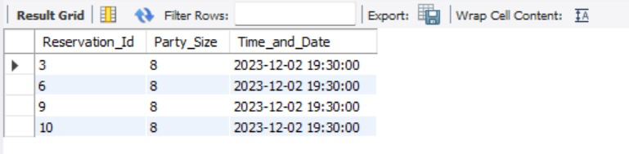

Query 2
English version | Analyze customer ordering habits in order to determine which items are popular or not.
Source for the query need in the SRS document | Page- 5 - Section – 2.2 - Point 8
SQL sentence | SELECT  oi.Item_Name,  SUM(oi.Item_Qty) AS TotalQuantityOrdered  FROM  Order_Items oi  GROUP BY  oi.Item_Name  ORDER BY  TotalQuantityOrdered DESC  LIMIT 1;
Example of returned rows (cropped screen caption) | 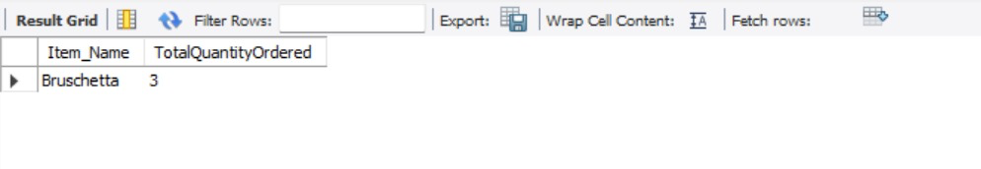

Query 3
English version | Generate receipts from orders and be able to store these receipts.
Source for the query need in the SRS document | Page- 5 - Section – 2.2 - Point 4
SQL sentence | SELECT  o.Order_Id,  c.email,  m.Item_Name,  oi.Item_Qty,  m.Item_Price,  oi.Item_Qty * m.Item_Price AS Item_Total  FROM  Orders o  JOIN  Order_Items oi ON o.Order_Id = oi.Order_Id  JOIN  Menu m ON oi.Item_Name = m.Item_Name  JOIN  Customers c ON o.email = c.email  WHERE  o.Order_Id = 2;
Example of returned rows (cropped screen caption) | 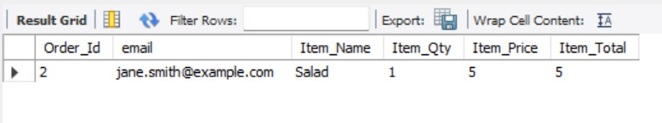

Query 4
English version | Analyze customer ordering habits in order to determine which items are popular or not.
Source for the query need in the SRS document | Page- 5 - Section – 2.2 - Point 8
SQL sentence | SELECT  Item_Name,  SUM(Item_Qty) AS TotalQuantity  FROM  Order_Items  GROUP BY  Item_Name  HAVING  SUM(Item_Qty) > 5;
Example of returned rows (cropped screen caption) | 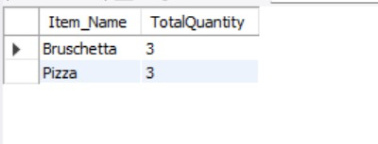

Query 5
English version | The system shall account for gratuities made by customers on credit card transactions and associate those funds with the server so that payment is issued with the employee’s payroll.
Source for the query need in the SRS document | Page – 9 – 3.5.1.5
SQL sentence | SELECT  o.Order_Id,  SUM(oi.Item_Qty * m.Item_Price) AS TotalOrderAmount,  p.Amount AS TotalPayment,  (p.Amount - SUM(oi.Item_Qty * m.Item_Price)) AS TipAmount  FROM  Orders o  JOIN  Order_Items oi ON o.Order_Id = oi.Order_Id  JOIN  Menu m ON oi.Item_Name = m.Item_Name  JOIN  Payment p ON o.Order_Id = p.Order_Id  GROUP BY  o.Order_Id, p.Amount  HAVING  (p.Amount - SUM(oi.Item_Qty * m.Item_Price)) > 0;
Example of returned rows (cropped screen caption) | 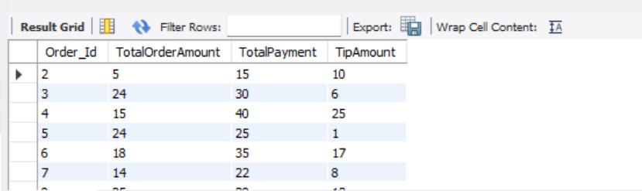

Query 6
English version | A status screen of all order item details for each table will be available to kitchen staff for all open orders.
Source for the query need in the SRS document | Page 9 – 3.5.1.3
SQL sentence | SELECT  Order_Id,  email,  Status  FROM  Orders  WHERE  Status <> 'Completed';
Example of returned rows (cropped screen caption) | 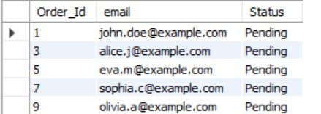

Query 7
English version | Analyze customer ordering habits in order to determine which items are popular or not. ( to find orders that include specific items and have a total order amount greater than a certain value. In this example, we'll find orders that include the item 'Pizza' and have a total amount greater than $20).
Source for the query need in the SRS document | Page- 5 - Section – 2.2 - Point 8
SQL sentence | SELECT  Order_Id,  email,  TotalOrderAmount  FROM (  SELECT  o.Order_Id,  o.email,  SUM(oi.Item_Qty * m.Item_Price) AS TotalOrderAmount  FROM  Orders o  JOIN  Order_Items oi ON o.Order_Id = oi.Order_Id  JOIN  Menu m ON oi.Item_Name = m.Item_Name  GROUP BY  o.Order_Id, o.email  ) AS OrderDetails  WHERE  'Pizza' IN (  SELECT DISTINCT  Item_Name  FROM  Menu  )  AND TotalOrderAmount > 20;
Example of returned rows (cropped screen caption) | 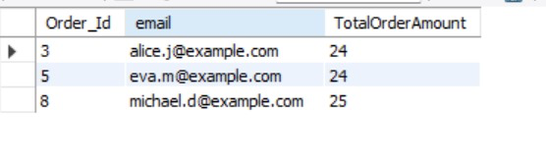

Query 8
English version | Analyze customer ordering habits in order to determine which items are popular or not. (Consider a scenario where you want to retrieve a list of items that are either frequently ordered or have a high unit price. For example, suppose you want to find items that have been ordered more than 50 times or have a unit price greater than $10)
Source for the query need in the SRS document | Page- 5 - Section – 2.2 - Point 8
SQL sentence | SELECT  Item_Name,  COUNT(*) AS OrderCount  FROM  Order_Items  GROUP BY  Item_Name  HAVING  COUNT(*) > 50  UNION  -- Query for items with a high unit price  SELECT  Item_Name,  MAX(Item_Price) AS MaxUnitPrice  FROM  Menu  GROUP BY  Item_Name  HAVING  MAX(Item_Price) > 10;
Example of returned rows (cropped screen caption) | 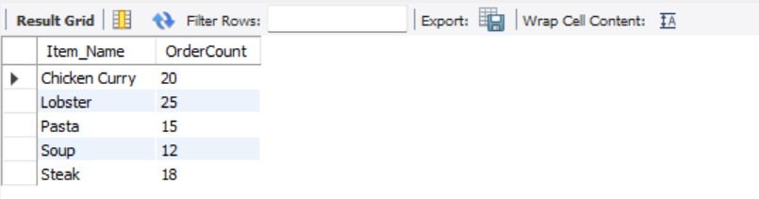

Query 9
English version | Retrieve the party size greater than avg party size for reservations made on each date.
Source for the query need in the SRS document | Page 45
SQL sentence | SELECT  Time_and_Date,  AVG(Party_Size) AS AveragePartySize  FROM  Reservation  GROUP BY  Time_and_Date  HAVING  AVG(Party_Size) > (  SELECT  AVG(Party_Size)  FROM  Reservation  );
Example of returned rows (cropped screen caption) | 



